Algorithm for file updates in Python

Project description
This is an example of using methods to organize and modify “allow_list.txt” by using the .remove( ), .split ( ), .read( ), .write( ), and .join ( ) functions.

Open the file that contains the allow list
This is the scenario where I am responsible for developing an algorithm that parses a file containing IP addresses that are allowed to access restricted content and removes addresses that no longer have access. By using the ‘with’ command with open(import_file, “r”) as file:, I programmed this argument first to pull the “allow_list.txt” as a file.

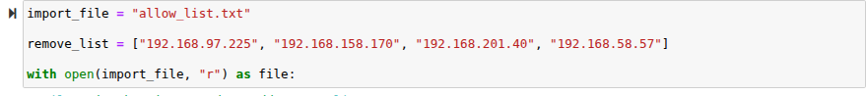

Read the file contents
Next, I have written a code that included the .read( ) method to convert the contents of the “allow_list.txt” file into a string so I could read it and store this in a variable called ip_addresses by writing the following code: ip_addresses = file.read( )

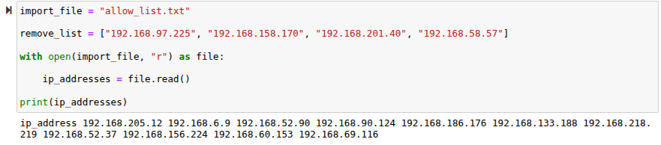

Convert the string into a list
In order for me to remove individual IP addresses from the list, I put this in list format by using the .split( ) method in order for me to convert the ip_addresses string into a list with the following code: ip_addresses = ip_addresses.split()
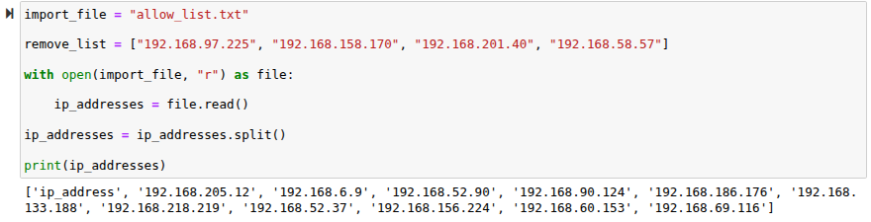

Iterate through the remove list
A second list called the remove_list contained all of the ip addresses that should be removed from the ip_addresses list. I have named the loop variable element by using the for method to write in the following instance: for element in ip_addresses: and if element in remove_list:

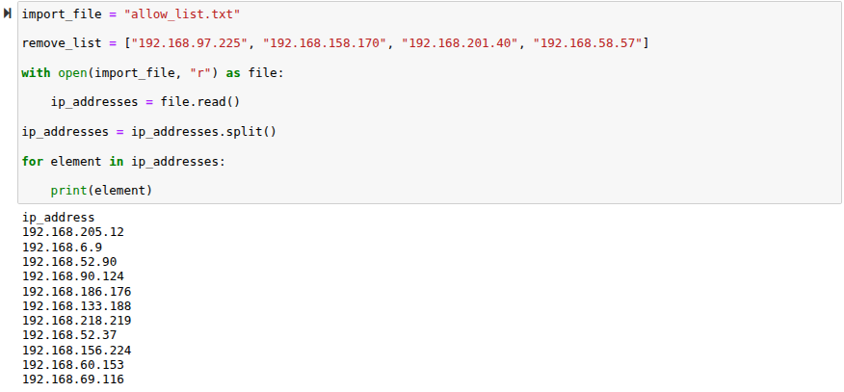

Remove IP addresses that are on the remove list
I then continue to use the .remove( ) method and apply it to the element inside for the augment in ip_addresses. By doing this it will remove all the IP addresses from the allow list that are also included on the remove_list. Also by using the .remove( ) method it is possible to use this because there are no duplicates in the ip_addresses list. Code written: ip_addresses.remove(element)

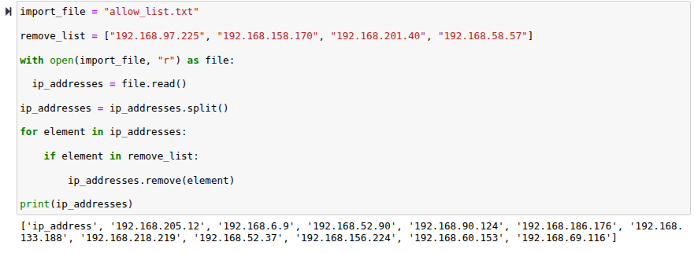

Update the file with the revised list of IP addresses
Now that I moved the IP addresses from the ip_address variable, I have re-joined this variable by using the .join( ) method. I have then used the with statement and the .write( ) method to write over the file assigned to the import_file variable: ip_address = “ “.join(ip_addresses ,
with open(import_file, “w”) as file: and file.write(ip_addresses)

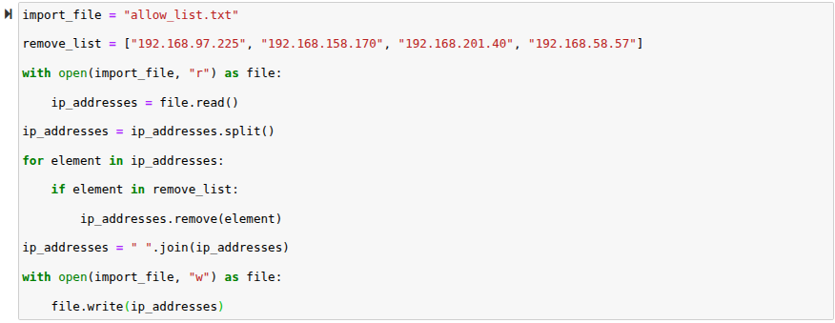

Summary
By using these methods and instances within the variables it concludes that the ip_addresses that was included in the remove_list variable, it states that I have written the Python codes necessary to execute these commands.

